
XCAMDEN
Software & Digital Solutions
Denell Jonas
denelljonas@gmail.com
+1-868-291-2390
denelljonas.com

PROJECT WORK PLAN
Job-Site Digital Forms & Reporting Platform
A mobile-first inspection, approval and reporting application
Prepared for
RESSCOTT LIMITED
Prepared by
Denell Jonas · Xcamden

Version 1.0 · 16 June 2026

Document Control
Document title | Project Work Plan — Job-Site Digital Forms & Reporting Platform
Prepared for | Resscott Limited
Prepared by | Denell Jonas, Xcamden
Version | 1.0
Date | 16 June 2026
Status | For client review and approval

Contents
Document Control 2
Contents 2
1. Project Overview 3
1.1 Objectives 3
2. Solution Scope 4
2.1 User Accounts & Manager Approval 4
2.2 Section 1 — Job-Site Start Evidence 4
2.3 Section 2 — Digital Forms 4
2.4 Manager Admin Dashboard 5
3. Process Workflow 6
Stage 1 — Onboarding & Access Control 6
Stage 2 — Job-Site Start Evidence (Section 1) 7
Stage 3 — Form Completion & Submission (Section 2) 8
Stage 4 — Manager Review & Report Conversion 9
4. Technical Approach 10
5. Deliverables 11
6. Indicative Timeline 11
7. Commercial Summary 12
8. Assumptions & Exclusions 12
9. Acceptance & Sign-Off 13

1. Project Overview
Xcamden will design, build and deploy a mobile-first web application that digitises Resscott Limited’s field workflow — from a technician arriving on site, through completing the company’s standard forms, to a manager reviewing the work and producing a polished, customer-facing report.
Today these forms (such as the Site Visit form for solar lighting) are completed on paper. The new platform reproduces each form digitally, captures mandatory photo/video evidence at the start and end of every job, and routes every submission to a manager for approval. Approved submissions can then be converted, on demand, into a branded customer-facing Inspection Report and downloaded as a PDF. The entire records database can also be exported to Excel.
Every user has their own account, so all work is fully traceable to the individual who performed it. Access to specific forms is granted by the manager, ensuring technicians only see the forms relevant to their role.

1.1 Objectives
- Eliminate paper — replace Resscott’s current paper forms with accurate digital replicas.
- Guarantee evidence — enforce mandatory start-of-job and end-of-job photo/video capture.
- Ensure accountability — individual accounts and an approval chain trace every record to its author.
- Speed up reporting — convert an approved submission into a customer-facing PDF report in one click.
- Centralise records — organised, searchable folders by form type, with full Excel export.

2. Solution Scope
The platform is organised into four functional areas, described below. The end-to-end process is illustrated by the workflow diagrams in Section 3.

2.1 User Accounts & Manager Approval
- A new user self-registers by creating an account; the request is sent to the manager for approval.
- The manager receives a notification, reviews the request, and selects which forms the user may complete.
- On approval, the account is activated and the user can log in. If declined, the user cannot log in.
- Each user has a separate account so that every action and submission is traceable to an individual.

2.2 Section 1 — Job-Site Start Evidence
- On starting a job, the user must upload a photo or video of the current state of the job site.
- The user adds mandatory notes describing what was observed and what the job will entail.
- Both the photo/video and the notes are required; the user cannot proceed to Section 2 until they are complete.

2.3 Section 2 — Digital Forms
The user selects a form to complete, seeing only the forms the manager has approved for their account. Each form is a digital replica of the document Resscott currently uses. The available forms are:
- Site Visit
- Job Inspections
- Solar Water Heater
- Job Ticket
- New Job Task
While completing a form, the user can attach photos or videos to the notes. At any point the user can either save the form as a draft to re-access later, or submit it. Before submission is possible, the user must upload a final photo or video confirming the job is complete. Submitting routes the form to the manager and triggers an approval notification.

2.4 Manager Admin Dashboard
- The manager logs in to an admin dashboard containing folders named for each form type.
- Each folder holds copies of all submitted forms of that type, with a clear indicator of whether a report has already been converted or still needs converting.
- If conversion is needed, the manager clicks Convert to generate the customer-facing Inspection Report, which can be downloaded as a PDF.
- If a report has already been converted, the manager can convert again (with a confirmation prompt) or simply re-download the existing PDF.
- The full records database can be exported to Excel whenever the manager requires it.

3. Process Workflow
The diagrams below capture the full job-site workflow that the application implements, broken into its four stages. They are based on the agreed process flow for the Resscott job-site solution.

Stage 1 — Onboarding & Access Control

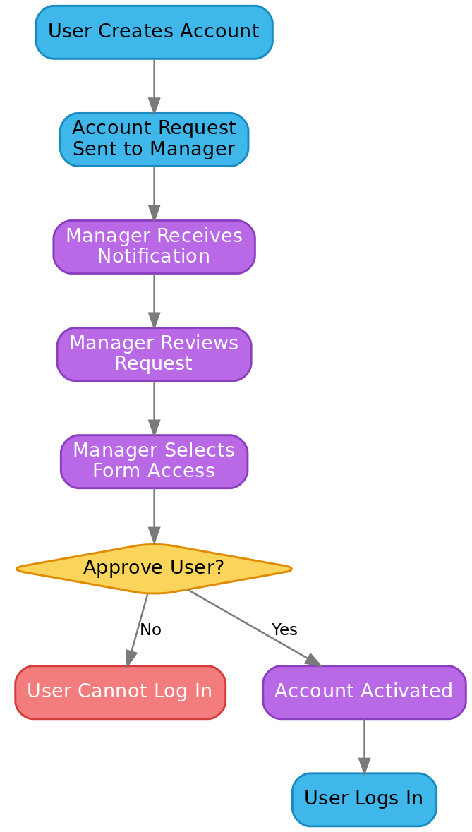
Figure 1: Account creation, manager review, form-access selection and approval.

Stage 2 — Job-Site Start Evidence (Section 1)

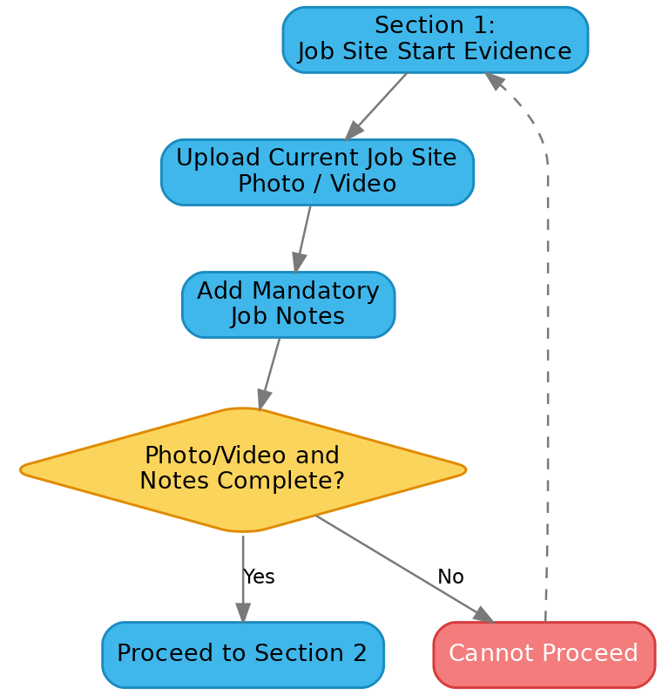
Figure 2: Mandatory photo/video and notes gate before the user may continue.

Stage 3 — Form Completion & Submission (Section 2)
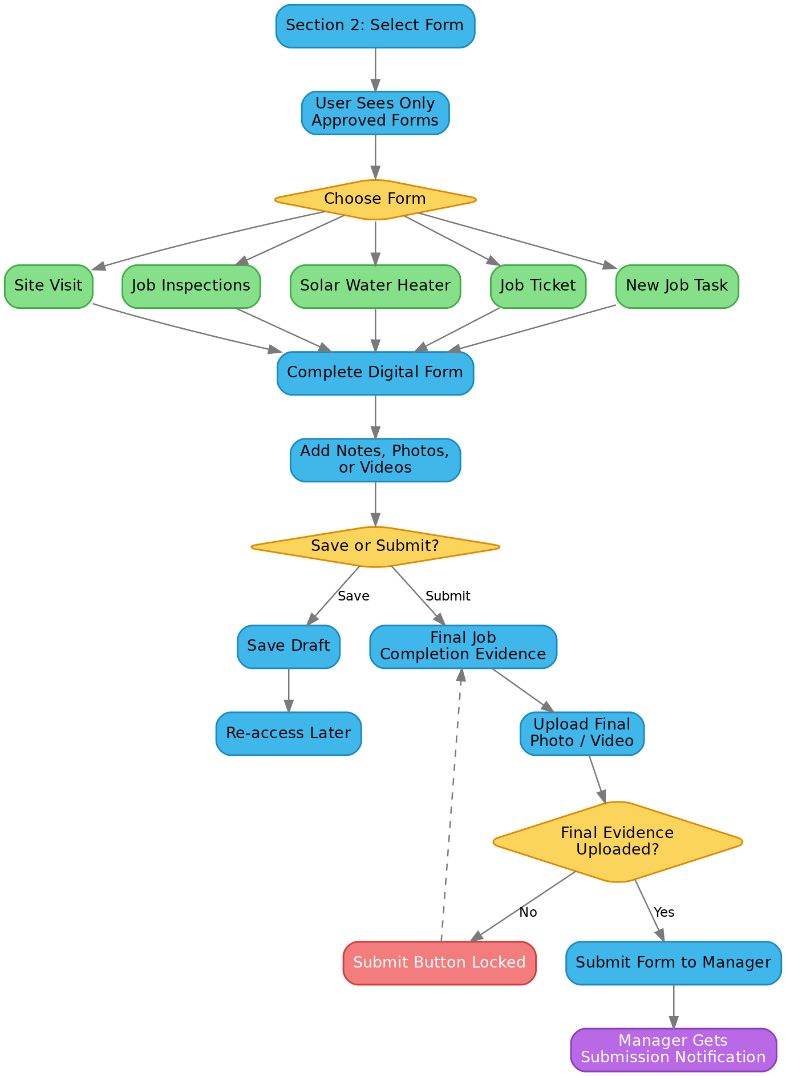
Figure 3: Form selection, completion, save-as-draft, final evidence gate and submission.

Stage 4 — Manager Review & Report Conversion
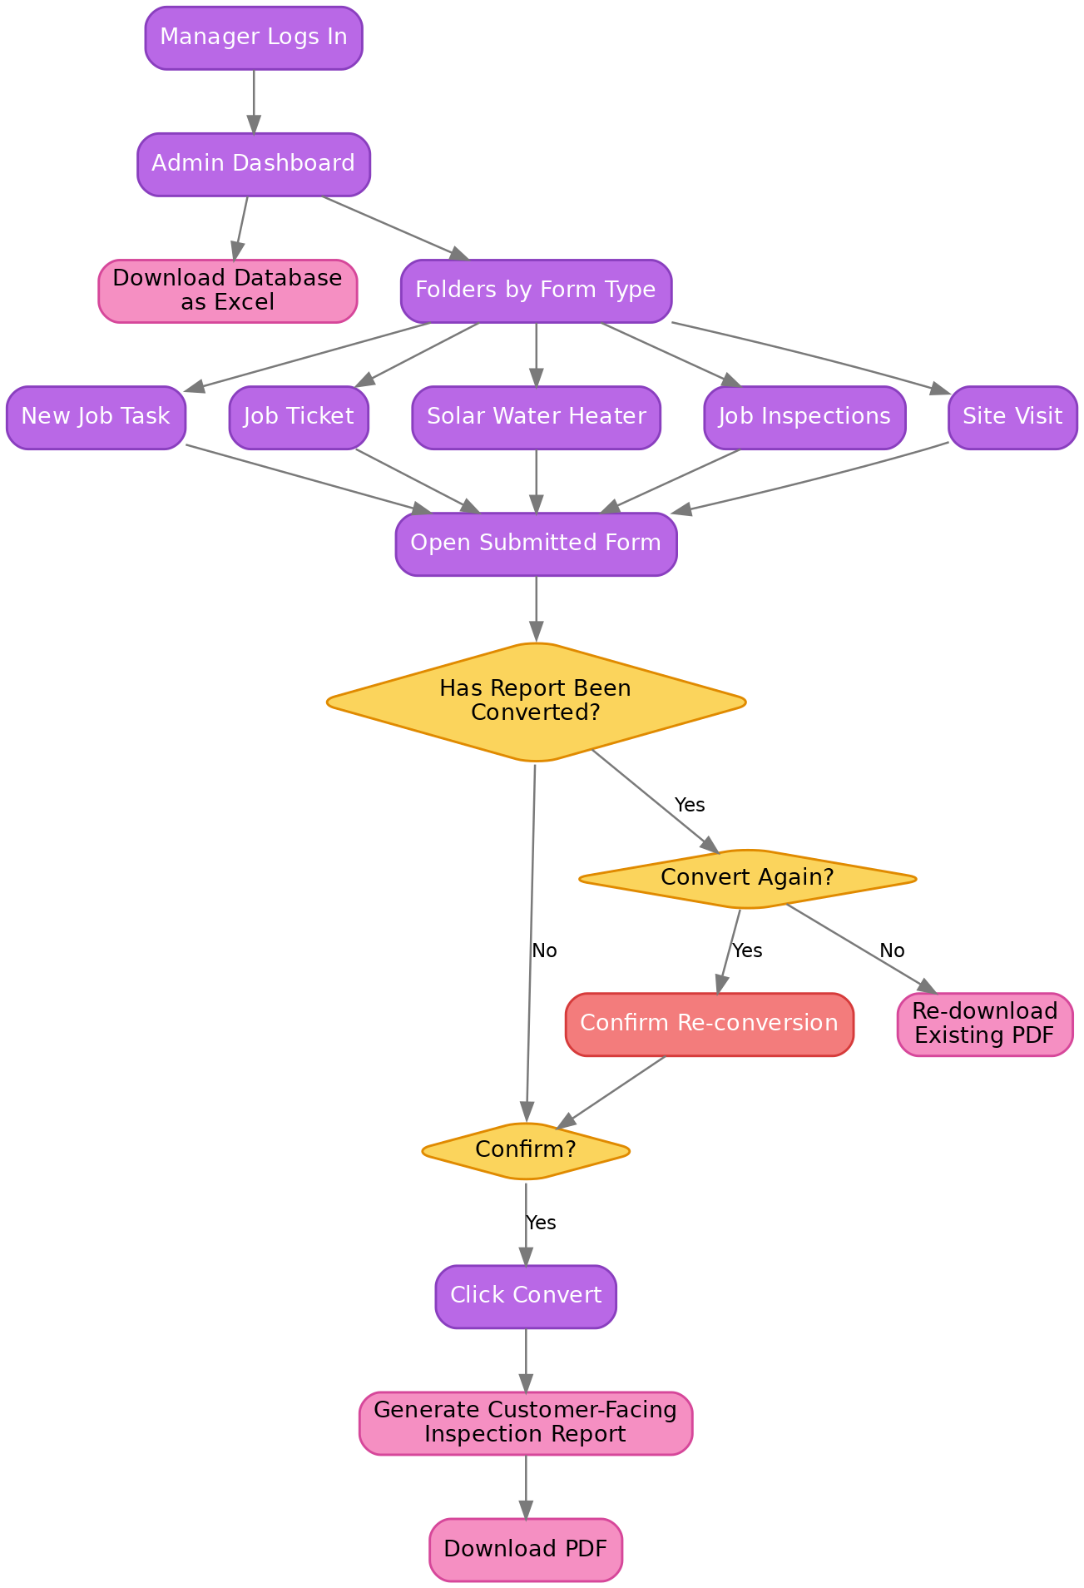
Figure 4: Admin dashboard, per-form folders, conversion to PDF report and Excel export.

4. Technical Approach
The application is delivered as a Progressive Web App (PWA), so it installs and runs like a native app on phones and tablets while remaining a single codebase that also works on desktop. This is ideal for field technicians who capture photos and video on their mobile devices.
Layer | Technology | Purpose
Front end | React + Vite + TypeScript, Tailwind CSS | Fast, responsive, mobile-first user interface
Mobile capture | Device camera (photo & video) | On-site evidence at start and completion of jobs
Backend & database | Convex (reactive database, server functions, file storage) | Real-time data, secure storage of media and submissions
Authentication | Convex Auth (email / password) | Individual accounts; manager-controlled access
Reporting | Server-side PDF generation | Customer-facing Inspection Report PDFs
Data export | Excel (.xlsx) export | Full database download for the manager
Hosting | Cloud hosting with continuous deployment | Reliable, always-available access

Key engineering guarantees built into the platform:
- Traceability — no public sign-up; the first manager is bootstrapped and every other account is created/approved by a manager.
- Mandatory evidence — the submit action is locked until the required start and completion media are uploaded.
- Reliable approvals — each approval updates the submission status and notifies the relevant party in a single, consistent operation.
- Real-time updates — managers see new submissions and users see approvals without refreshing.

5. Deliverables
- A deployed, mobile-first web application (PWA) covering all four functional areas above.
- Digital replicas of the five Resscott forms: Site Visit, Job Inspections, Solar Water Heater, Job Ticket and New Job Task.
- Manager admin dashboard with per-form folders, conversion status, one-click PDF report generation and Excel export.
- Individual user accounts with manager-controlled, per-form access.
- Customer-facing Inspection Report PDF template.
- Deployment to live hosting, plus a brief handover/orientation for the manager and users.

6. Indicative Timeline
The project is delivered in five phases. Durations are indicative and run in business days; they will be confirmed on project kick-off.
Phase | Activities | Indicative duration
1. Discovery & form mapping | Confirm each paper form’s fields and rules; finalise the Inspection Report layout | 1 week
2. Accounts & access | Registration, manager approval, per-form access control | 1 week
3. Field workflow | Section 1 evidence, the five digital forms, drafts, final-evidence gate, submission | 2–3 weeks
4. Manager dashboard & reporting | Folders, conversion to PDF, re-convert/re-download, Excel export, notifications | 2 weeks
5. Testing, deployment & handover | End-to-end testing, deploy to live hosting, orientation | 1 week

Estimated total elapsed time: approximately 7 to 8 weeks, subject to timely feedback and form sign-off from Resscott.

7. Commercial Summary
Item | Description | Amount
Project fee | Design, development, testing and deployment of the complete platform and all deliverables in Section 5 | TTD $10,000.00
Hosting & backend (optional) | Convex backend subscription — reactive database, server functions and file/media storage. Optional, billed to Resscott or arranged as required. | approx. US $25.00 / month

Total project fee (one-time) | TTD $10,000.00

- All amounts are quoted in Trinidad & Tobago Dollars (TTD) unless otherwise stated.
- The Convex hosting subscription is optional and listed separately; the monthly cost depends on usage and is billed by the provider.
- Payment schedule and any third-party costs to be confirmed in the engagement agreement.

8. Assumptions & Exclusions
- Resscott will provide the current paper forms and confirm all fields, options and rules for each digital replica.
- Resscott will supply branding (logo, colours) and content for the customer-facing Inspection Report.
- One company / single tenant; one manager (admin) role and field-user accounts as described.
- Pricing covers the scope in this document; new forms or significant changes after sign-off are handled as a separate change request.
- Ongoing maintenance and support after handover can be arranged under a separate agreement.

9. Acceptance & Sign-Off
By signing below, Resscott Limited confirms agreement to the scope, timeline and commercial terms set out in this work plan, authorising Xcamden to proceed.

For Resscott Limited | For Xcamden
Name: ____________________________ | Name: Denell Jonas
Signature: _______________________ | Signature: _______________________
Date: ____________________________ | Date: ____________________________

Thank you for the opportunity to work with Resscott Limited. Please direct any questions to Denell Jonas at denelljonas@gmail.com or +1-868-291-2390.

